**SECTION A**

1.Name one type of soil.

_________________________________________________________________

2. Write down the use of plants to people.

_________________________________________________________________

3. What is food?

_________________________________________________________________

4. Name the seeds below.

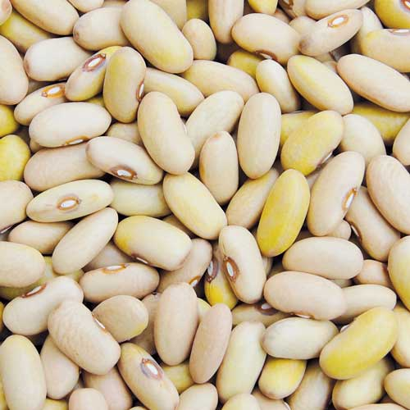

___________________________________

5. Give one way we care for animals.

_________________________________________________________________

6. Which type of soil is best for making pots.

_________________________________________________________________

7. Write down one source of water in your area.

_________________________________________________________________

8. What are living things?

_________________________________________________________________

9. Name the home of a cow.

_________________________________________________________________

10. Write any one example of living things.

_________________________________________________________________

11. Give one reason why animals move from one place to another.

_________________________________________________________________

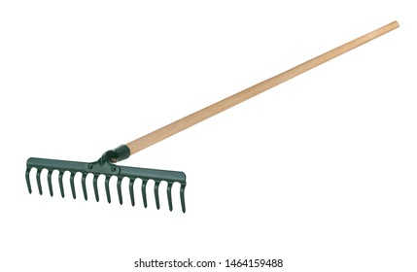12. Name the garden tool below.

_________________________________________

13. Write down one characteristic of living things.

_________________________________________________________________

14. Name one animal that provides us with milk.

_________________________________________________________________

15. Give one example of domestic animals.

_________________________________________________________________

16. Which part of the plant holds firmly in the soil.

_________________________________________________________________

17. Name one animal item made from animal skin.

_________________________________________________________________

18. In which season do farmers prepare the land.

_________________________________________________________________

19. Name one element of weather.

_________________________________________________________________

20. Write down one danger of wild animals to our lives.

_________________________________________________________________

21. Name any one example of animals eaten by people.

_________________________________________________________________

22. What helps birds to fly in air.

_________________________________________________________________

23. Write any one use of soil to people.

_________________________________________________________________

24. Mention one type of germination.

_________________________________________________________________

25. Name the soil layer with a lot of humus.

_________________________________________________________________

26. In which direction does the sun set.

_________________________________________________________________

27. What is wind?

_________________________________________________________________

28. What do we get from a bee?

_________________________________________________________________

29. Give one example of wild animals.

_________________________________________________________________

30. Name one animal that eats grass.

_________________________________________________________________

31. What garden tool is used to harvest cassava?

_________________________________________________________________

32. Name any one source of water.

__________________________________________________________________

33. Where does the sun rise from?

_________________________________________________________________

34. Give one person who use the compass in work.

_________________________________________________________________

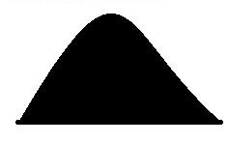35. Name the map symbol below.

__ ________________________________________

36. Write the name of your school.

_________________________________________________________________

37. In which district is your school found?

_________________________________________________________________

38. Who heads a family?

_________________________________________________________________

39. What is the work of a mother at home?

_________________________________________________________________

40. Who heads a school? _________________________________________________________________

**SECTION B**

41. Name four wild animals.

i)_________________________________________________________________

ii)_________________________________________________________________

iii)________________________________________________________________

iv)________________________________________________________________

42. Match list A to list B correctly.

**A B**

Fish den

Horse nest

Lion water

Bird stable

43. a) List any three ways water is used at home.

i)_________________________________________________________________

ii)_________________________________________________________________

iii)________________________________________________________________

b) What is the main source of water?

__________________________________________________________________

44. a) Write **true** or **false**.

Nimbus clouds bring rain_________________________

Birds use teeth to fly_____________________________

Yams grow well in and soil________________________

Some insects spread diseases_______________________

45. a) Write any two ways people care for crops in the garden.

i)_________________________________________________________________

ii)_________________________________________________________________

b) Mention two examples of crops in the environment.

i)_________________________________________________________________

ii)_________________________________________________________________

46. Match the animals to their movements.

**Animal movement**

Butterfly swims

Goat hops

Crocodile flies

Frog walks

47. Name the four things used to clean our bodies.

i)_________________________________________________________________

ii)_________________________________________________________________

iii)________________________________________________________________

iv)________________________________________________________________

48. a) What instruments is used to show directions.

__________________________________________________________________

b) Name the four main cardinal points of a compass.

i)_________________________________________________________________

ii)_________________________________________________________________

iii)________________________________________________________________

iv)________________________________________________________________

49. Give four people found in your family.

i)_________________________________________________________________

ii)_________________________________________________________________

iii)________________________________________________________________

iv)________________________________________________________________

50, Write down any four important places in our sub county.

i)_________________________________________________________________

ii)_________________________________________________________________

iii)________________________________________________________________

iv)________________________________________________________________

51. a) Mention two things sold in a market.

i)_________________________________________________________________

ii)_________________________________________________________________

b) List any two groups of people found in the school.

i)_________________________________________________________________

ii)_________________________________________________________________

52. In the space below draw and name four fruits.

|  |  |  |  |
| --- | --- | --- | --- |
|  |  |  |  |
|  |  |  |  |

53. What is the use of these garden tools?

A hoe _____________________________________________________________

A panga ___________________________________________________________

A watering can___________________________________________________

A rake__________________________________________________________

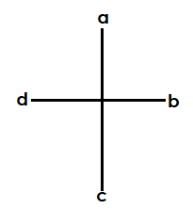54. Name the drawn cardinal points on the compass.

a_________________________________________________________________

b_________________________________________________________________

c_________________________________________________________________

d_________________________________________________________________

55. Name the four elements of a map.

i)_________________________________________________________________

ii)_________________________________________________________________

iii)________________________________________________________________

iv)________________________________________________________________